**Case Studies & Guesstimates for E-Commerce Industries**

To begin with, the e-commerce industry has revolutionized shopping by providing convenience, variety, and accessibility. It eliminates geographical boundaries and gives businesses the power to reach millions instantly.The e-commerce industry has fundamentally transformed the way people shop and conduct business, becoming a vital part of the global economy. In today's era, its importance is highlighted by the convenience and accessibility it offers, allowing consumers to shop anytime and anywhere. E-commerce breaks down geographical barriers, enabling businesses to reach a global audience and fostering international trade. It also brings cost efficiencies, reducing overhead costs compared to traditional brick-and-mortar stores. The industry thrives on innovation, with advancements in technology continually enhancing the shopping experience.

Data scientists play a crucial role in the growth and evolution of e-commerce. Their expertise in data analysis helps businesses understand customer behaviour, preferences, and purchasing habits, enabling personalised marketing and improved customer experiences. They optimize inventory management through predictive analytics, ensuring products are available when needed while minimising excess stock. Data scientists also develop dynamic pricing strategies, analyse market trends, and enhance fraud detection systems to protect both businesses and customers. By leveraging data, they help e-commerce platforms improve customer service and streamline operations, driving growth and maintaining a competitive edge in the market.

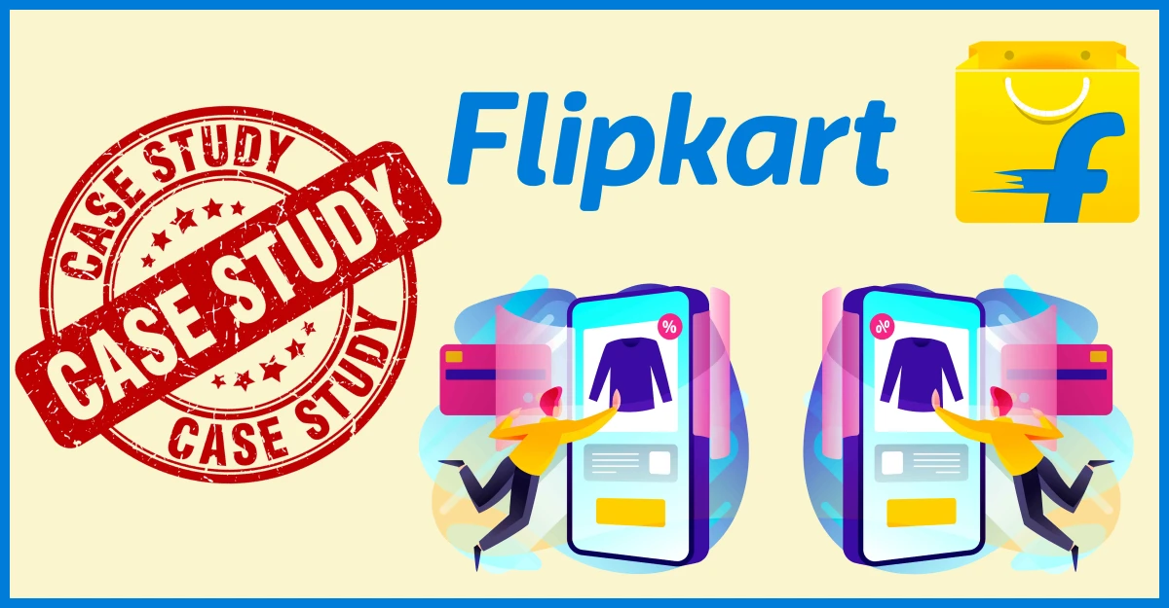

## **Introduction**

Flipkart is a household name in India’s e-commerce space. Launched in 2007 by two IIT Delhi graduates, Sachin Bansal and Binny Bansal , it started out as an online bookstore run from a two-bedroom apartment. Over time, Flipkart grew into one of India’s largest online marketplaces, offering everything from electronics to clothing, groceries to furniture. It played a major role in transforming how Indians shop, especially in tier 2 and tier 3 cities.

Flipkart acts like a **bridge** between sellers and buyers. Sellers from all over India list their products on Flipkart, and customers can buy anything they want — mobiles, clothes, furniture, groceries, and much more.

Customers can shop through the **Flipkart website** or **Flipkart app**, both designed to be simple and friendly. Flipkart also takes care of:

* Managing products in the system
* Handling payments securely
* Making sure deliveries happen fast
* Helping customers with any problems
* Ensuring easy returns and refunds

Flipkart’s biggest strength is that it made online shopping possible for everyone, even for people who had never shopped online before, by using **cash on delivery**, **easy returns**, and **supporting Indian languages**.

### **Flipkart's Big Turning Point – Walmart Acquisition (2018)**

In 2018, **Walmart**, the world’s largest retailer, **bought a 77% share in Flipkart** for **$16 billion**. This was a **huge global deal**, one of the **biggest in e-commerce history**.  
 🔹 **Why it matters:** It showed that global companies had strong confidence in India's e-commerce market — and especially in Flipkart’s potential to grow.

### **Flipkart is Now a Digital Ecosystem, Not Just a Shopping Site**

Today, Flipkart offers **much more than just products online** — it has become a **full ecosystem**. Here's how:

* **Ekart** – Its **own delivery/logistics company** that makes sure orders reach customers quickly and reliably.
* **Myntra** – A **fashion-focused** platform (owned by Flipkart) that offers clothes, accessories, and lifestyle products.
* **Cleartrip** – A **travel booking** platform (also owned by Flipkart) for flights, hotels, etc.
* Other verticals: Flipkart also offers groceries, mobile phones, home goods, and even financial services.

### **User Base & Impact**

* It now has **400+ million users** (that's more than the population of the USA!).
* Flipkart’s goal is to make **online shopping easy, affordable, and trustworthy** for **all Indian customers**, even in small towns.

# **1.Product Dissection**

**1. Platform Selection**

**Question:** Choose a leading platform from a domain related to the e-commerce industry. Justify your selection by discussing the platform's popularity, impact, and relevance in its industry.

**Answer:** I chose Flipkart because it’s one of India’s biggest and most trusted e-commerce platforms. It changed the way people shop online, especially with features like cash on delivery and fast delivery to remote areas. After Walmart bought it, Flipkart grew even more and expanded into fashion, travel, and payments. It’s a great example of how a company can grow and adapt to serve millions of people."

### **Popularity**

Flipkart is one of the most well-known and trusted e-commerce platforms in India. It serves millions of customers in both cities and small towns. Thanks to its wide range of products, exciting sales (like the Big Billion Days), and easy return policies, Flipkart has become a favorite among Indian online shoppers.

Flipkart is one of the most popular e-commerce platforms in India. With **over 400 million registered users**, it has a vast customer base across urban and rural regions. During big sale events like the **Big Billion Days**, Flipkart attracts millions of users and records billions in sales, demonstrating its high customer engagement.

### **Impact**

Flipkart has changed how people in India shop. It helped small sellers sell their products online, introduced safe digital payments, and improved delivery services through its own network (Ekart). Flipkart also started trends like flash sales, budget-friendly smartphones, and affordable EMIs — helping many more people shop online for the first time.

Flipkart revolutionized online retail in India by:

* Introducing **Cash on Delivery (CoD)**, which built trust in digital transactions.
* Creating a **robust logistics network (Ekart)** to reach remote areas.
* Supporting **small sellers and MSMEs** by giving them access to a national market.  
   Its innovations have shaped consumer behavior and set new benchmarks in Indian e-commerce.

### **Relevance**

As more people in India use smartphones and the internet, Flipkart keeps growing. It uses data and technology to show users what they want, deliver orders faster, and offer better prices. Flipkart is important in both B2C (selling to customers) and B2B (selling in bulk to businesses). It continues to play a key role in India’s digital and shopping future.

In today’s digital economy, Flipkart remains highly relevant because:

* It is backed by **Walmart** (77% stake, $16 billion acquisition in 2018), giving it global reach and capital.
* It has diversified into areas like fashion (Myntra), travel (Cleartrip), groceries, and fintech (Flipkart Pay Later).
* It continues to compete with giants like Amazon, driving innovation and better services for consumers.

# **2. Core Features and Functionalities**

**Question:** Research and list the core features and functionalities of the selected platform. Describe how these features contribute to the platform’s success and user engagement.

Flipkart is loaded with smart features designed to make online shopping easy, fun, and safe. Here’s a closer look at some of its standout functionalities:

### **1. Personalized Recommendations**

Flipkart uses machine learning to understand your behavior — what you browse, what you buy, even how long you look at something. Based on this, it shows personalized product suggestions on your home screen, improving your shopping experience over time.

### **2. Smart Search and Filters**

The search engine is fast and intelligent. You can use voice search, type in regional language, or even apply filters like price, brand, rating, delivery time, etc., to find exactly what you need in seconds.

### **3. Cash on Delivery (CoD)**

A game-changing feature in India, CoD allowed customers without online payment access to trust the platform. Even now, a large number of users prefer to pay only after receiving the product.

### **4. Ekart Logistics**

Flipkart's own delivery service, Ekart, ensures fast and safe delivery. It operates in thousands of pin codes and even supports **same-day or next-day delivery** for many cities.

### **5. Easy Returns and Refunds**

If a product doesn’t match expectations, Flipkart allows easy returns, replacements, or refunds — often picked up from your doorstep. This has built massive customer trust.

### **6. Multiple Payment Options**

From UPI, net banking, credit/debit cards to Flipkart Pay Later and EMI options — users have full control over how they want to pay. This flexibility is a big plus for buyers across income groups.

### **7. Regional Language Support**

To break the language barrier, Flipkart supports multiple Indian languages like Hindi, Tamil, and Kannada. This makes online shopping more inclusive and accessible to non-English speakers.

### **8. Flash Sales & Offers**

Events like **Big Billion Days** bring huge discounts and exclusive product launches making shopping affordable and exciting for millions of users.

These sales are advertised heavily and often drive record-breaking purchases within hours.

## **Contribution to Success and User Engagement**

Flipkart’s success is not just luck — it comes from smart strategies that keep users happy and engaged:

* **Trust Building:** With cash on delivery, easy returns, and genuine sellers, Flipkart made people trust online shopping.
* **Easy Shopping Experience:** A clean website and app design, smart filters, and regional languages made shopping simple for everyone, even first-time internet users.
* **Fast and Reliable Delivery:** Ekart made sure products reach customers quickly, making them come back again and again.
* **Attractive Offers:** Regular discounts, festive sales, and special deals created excitement and increased customer purchases.
* **Understanding Indian Needs:** Flipkart knew that Indian customers care about affordability, trust, and convenience. It kept adding features like EMI options, local language support, and wide delivery reach to even small towns.
* **Good Customer Support:** Flipkart’s quick help for refunds, exchanges, and delivery issues made users feel cared for and respected.

# **3. Real World Problems**

**Question:** Identify the real-world problems that the platform aims to solve. Discuss how the platform addresses these problems through its features and functionalities.  
 **Answers: Real-World Problems Addressed by Flipkart**

**Affordable Access to Goods**

* **Problem***:* High prices and limited variety in physical retail stores.
* **Solution***:* Flipkart offers competitive prices, discounts, and a wide product selection through online sellers.

**Delivery Reach in Remote Areas**

* **Problem***:* Customers in rural or Tier III cities lack access to diverse products.
* **Solution***:* Flipkart’s Ekart logistics enables deep reach across India, even in remote areas.

**Lack of Product Information and Reviews**

* **Problem***:* Offline shopping lacks transparency.
* **Solution***:* Flipkart provides detailed specifications, images, customer reviews, and Q&A sections.

**Uncertain Delivery Times**

* **Problem***:* Lack of trust in timely delivery.
* **Solution***:* Flipkart ensures real-time tracking and estimated delivery times to build transparency and trust.

**Scattered Customer Experience**

* **Problem***:* Inconsistent user experience and product availability across regions.
* **Solution***:* Flipkart standardizes product offerings, pricing models, and uses AI for tailored customer experience.

## **How Flipkart Addresses These Problems**

**1. Bringing Products to Small Cities :**

Many people in small towns can’t find branded or good-quality products in local stores. Flipkart delivers all kinds of products to every corner of India so everyone can shop easily.

**2. Making Things Affordable:**

People in India care a lot about price. Flipkart offers discounts, exchange deals, and EMI options so customers can buy what they need without spending too much.

**3. Saving Time with Easy Shopping:**

Instead of going to crowded markets, people can now shop anytime from their phones. Flipkart gives 24/7 access, doorstep delivery, and many payment options like UPI, cash on delivery, and cards.

**4. Offering More Choices:**

In small towns, people don’t get much variety in local stores. Flipkart has a huge collection—clothes, gadgets, home items—so customers can find everything in one place.

**5. Fast and Safe Delivery**

Many areas didn’t have good delivery services. Flipkart built its own delivery system called Ekart, which makes sure products reach customers on time—even in far-off places.

# **4.Database Management & Schema Design**

### **Schema Design**

The database schema for **Flipkart** should be designed to capture its essential features and operations, facilitating efficient data organization and supporting a smooth shopping experience. The following outlines the primary entities, their attributes, and interconnections tailored to Flipkart’s e-commerce ecosystem.

.

**Key Entities and Attributes**

Designing a database schema for a platform like **Flipkart**, India’s leading e-commerce marketplace, involves considering several key entities related to online retail. An e-commerce platform typically includes customers, products, orders, sellers, and user reviews. Below is a simplified schema design for such a platform, outlining the main entities and their interconnections.

1. **Customer table:** All the customer details will be stored in this table.

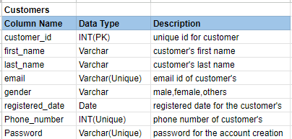

1. **Product Table:** All the information about the product table will be stored in this table.

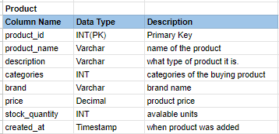

1. **Address Table:** Customer’s addresses will be stored in this table.

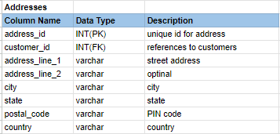

1. **Orders Table:** All the details about orders will be stored in this table.

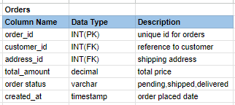

1. **Order Item Table:** All the details about order items will be stored in this table.

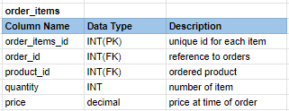

1. **Payments:** All the payment details will be stored in this table.

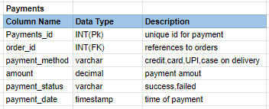

1. **Cart Table:** All the cart details will be present in this table.

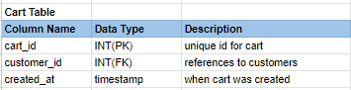

1. **Cart Item Table:** All the cart item details will be in this table.

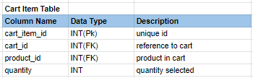

1. **Review Table:** All the reviews from the customer details will be stored in this table.

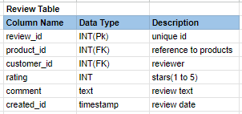

1. **Product Image:** All the product image details will be present in this table.

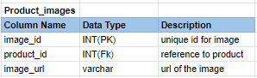

To visualize the relationships between the various tables in a **e-commerce platform database** **schema**, we can create a **schema relationship table** that outlines how the tables are linked via foreign keys and references

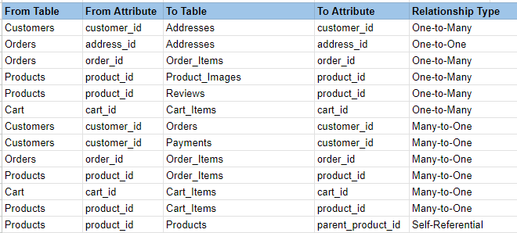

## **5. ER Diagram Creation**

# **Revenue and Profit Growth Strategies**

**Question:** After completing the product dissection and schema design steps for the chosen platform, conduct a comprehensive case study on the above chosen industry. Your goal is to identify and propose strategies to increase the **profit of the industry by at least 25%**.

Flipkart, India’s leading e-commerce platform, generated INR 34,610 crore in FY20 with a 48% market share. The schema design (e.g., Customers, Orders, Products) supports analyzing sales, customer behavior, and operational efficiency.

**Revenue Growth Recommendations:**

* **Expanded Product Personalization with AI:**
  + Leverage the Products and Customers tables to use AI (Flipkart’s 200+ ML models) for tailored recommendations.
  + **Strategy**: Increase average order value by 15% by suggesting complementary items (e.g., cases with smartphones) using Order_Items data.
  + **Impact**: Higher sales per customer, targeting 350 million users, could boost revenue by 10-15%.
* **Enhance Big Billion Days Campaigns:**
  + Analyze Orders and Order_Items from past events (e.g., 1.3 million phones in 20 hours, 2017) to optimize promotions.
  + **Strategy**: Introduce tiered discounts and bundle offers, increasing order frequency by 20%.
  + **Impact**: Additional 5-8% revenue growth from increased transaction volume.
* **Target Tier 2+ Cities:**
  + Use Addresses (e.g., city, state) to identify underserved regions.
  + **Strategy**: Expand logistics (e.g., Flipkart Minutes) with localized marketing, growing customer base by 10%.
  + **Impact**: New customers could contribute 5-7% to revenue.

#### 

#### **Customer Retention and Loyalty Programs:**

* **Strategy**: Introduce a loyalty program using **Customers** and **Orders** data to reward repeat purchases.
  + Offer points per order (tracked via order_id), redeemable for discounts.
  + Use gender and categories (e.g., “Men’s Clothing,” “Electronics”) to personalize rewards.
* **Impact**: Increase customer lifetime value by 10-15%, as loyal customers (e.g., 350 million base) spend 20% more annually.
* **Profit Contribution**: Adds 5-8% to profit by boosting repeat sales without heavy marketing costs.

#### **Operational Efficiency through Technology:**

* **Strategy**: Enhance operational efficiency using schema data and technology.
  + Analyze Addresses and Orders to optimize delivery routes via AI (e.g., eKart).
  + Use Products (stock_quantity) and Order_Items to improve demand forecasting, reducing delivery delays.
* **Impact**: Faster deliveries (e.g., Flipkart Minutes) improve customer satisfaction, increasing order frequency by 10%.
* **Profit Contribution**: Adds 3-5% to profit by reducing delivery failures and enhancing customer trust.

### **Leveraging NLP for User Feedback Analysis**

To enhance customer satisfaction and reduce churn, Flipkart can apply Natural Language Processing (NLP) techniques to analyze large volumes of user-generated feedback, such as product reviews, return reasons, and support queries.

Strategy:

* Use sentiment analysis to identify dissatisfaction trends.
* Apply topic modeling (e.g., LDA, BERTopic) to discover common complaint themes like “late delivery,” “defective items,” or “poor packaging.”
* Implement Named Entity Recognition (NER) to tag products, sellers, and locations responsible for recurring issues.

Impact:

* Enables targeted improvements in product quality, seller performance, and logistics.
* Enhances user trust and retention.
* Expected to boost repeat purchases and reduce return rates, contributing up to 5–7% revenue growth.

### **Customer Segmentation for Personalized Marketing**

Using clustering techniques (like K-Means or DBSCAN) on customer behavioral data (Orders, Products viewed, Purchase frequency, Categories browsed), Flipkart can segment its 350M+ user base into distinct groups.

Strategy:

* Identify high-value, deal-seeking, or infrequent buyers.
* Tailor marketing strategies, discounts, and recommendations per segment.  
  + For example: Gamers get tech deals, parents get baby product bundles, etc.
* Improve product discovery using segment-based recommendation engines.

Impact:

* Drives higher engagement and conversions.
* Increases average order value (AOV) and lifetime customer value.
* Could drive 8–10% revenue growth through better personalization and user targeting.

### **Predicting Product Demand with Time Series Analysis**

Flipkart can use **time series analysis** to understand and predict the demand for different products over time. This means looking at past sales data to find patterns—like what sells more during festivals, weekends, or seasonal changes.

For example:

* Sales of winter jackets go up in November and December.
* Mobile phones sell more during the **Big Billion Days** sale.
* Grocery items may sell more on weekends.

By using this analysis, Flipkart can:

* **Stock the right products at the right time**, reducing overstock or out-of-stock issues
* **Plan discounts and promotions** better
* **Improve delivery times** by preparing inventory in advance

This helps reduce waste, saves money, and improves customer satisfaction — which leads to **more repeat purchases and better profit margins**.

Time series analysis can contribute **4–6%** growth in profits by improving planning and reducing losses.

### **Quick Delivery Option for Special Occasions**

Many people use Flipkart to buy gifts for birthdays, anniversaries, or festivals. In such cases, **delayed delivery can ruin the whole experience**. That’s why offering a **quick delivery option**, like **"Flipkart Minutes"**, can be very helpful.

**Example:** If someone orders a gift for a friend’s birthday just 2 days before, and it doesn’t arrive on time, they’ll be disappointed. But if Flipkart offers **1-day or same-day delivery**, it increases the chances of customer satisfaction and loyalty.

**Benefits:**

* Helps customers trust Flipkart for urgent needs
* Encourages more purchases during festive or gifting seasons
* Increases repeat customers who rely on fast service

By improving delivery speed in key locations and during peak times, Flipkart can boost **customer happiness and drive 3–5% more profit**.

**Conclusion**

The proposed strategies for Flipkart, encompassing Revenue Growth Recommendations and additional profit-enhancing approaches, demonstrate a robust pathway to achieve a 25% profit increase. By leveraging AI for personalized product recommendations, optimizing Big Billion Days campaigns, targeting tier 2+ cities, implementing loyalty programs, and improving operational efficiency through technology, Flipkart can boost revenue by 10-15%, 5-8%, 5-7%, 10-15%, and 3-5% respectively. These initiatives, utilizing the schema’s data (Customers, Orders, Products, etc.), capitalize on Flipkart’s 350 million customer base and 150 million products, enhancing sales and customer satisfaction while streamlining operations. Collectively, these efforts are projected to elevate profit margins, ensuring sustainable growth and a competitive edge in the e-commerce industry.

**PART - II**

**1. What percentage of total retail sales in 2025 will be conducted through e-commerce platforms?**

| **Step** | **Details** | **Calculation** |
| --- | --- | --- |
| Total Population (India, 2025) | Estimated national population | 1.4 billion |
| Internet Penetration | 60% of population has internet access | Internet users = 1.4B × 0.6 = **840 million** |
| E-Commerce Adoption | 50% of internet users shop online | E-commerce users = 840M × 0.5 = **420 million users** |
| Avg Annual Spend per E-comm User | $330 per user annually | Total e-commerce sales = 420M × $330 = **$138.6 billion** |
| Total Retail Sales (India, 2025) | Grown from $900B in 2022 at ~9% CAGR | 900 × (1+0.09)^3=1165.5 billion ≈ **$1.17 trillion** |
| E-commerce Share of Retail Sales | ($138.6B / $1.17T) × 100 | ≈ **11.8% - 12%** |

So, E-commerce Share of Retail Sales percentage increase in India in 2025 is approximately **11 -12%.**

**2. How much will the average online shopper spend annually in 2025?**

| **Step** | **Details** | **Calculation** |
| --- | --- | --- |
| India's E-commerce Market Size (2025) | Projected from multiple sources | $137 billion |
| Online Shopper Base (2025) | Internet penetration ~60% → 840 million people. Assume ~50% of them shop online | 840M × 0.5 = **420 million online shoppers** |
| Average Spend per Shopper (Annual) | Total market / total shoppers | $137B ÷ 420M = **$326 per person per year** |

So, In E- commerce platform the average online shopper spend annually in 2025 is $326.

**3. What will be the market share of mobile e-commerce (m-commerce) in total e-commerce sales in the next five years?**

| **Step** | **Details** | **Calculation** |
| --- | --- | --- |
| Smartphone Users in India (2030) | Smartphone penetration rising to ~80% of population by 2030 | 1.4B × 0.8 = **1.12 billion users** |
| Internet Users on Mobile | Most Indians access internet via mobile (~95%) | 1.12B × 0.95 = **1.06 billion mobile internet users** |
| E-commerce Shoppers via Mobile | Assume 90% of online shoppers use mobile (growing trend) | 420M × 0.9 = **378 million m-commerce users** |
| Behavioral Trend | Flipkart, Amazon, and Meesho report ~80–90% traffic from mobile | Supported by industry reports |
| Projected M-commerce Share of E-comm Sales (2030) | Based on trends and growth | **85–90%** of total e-commerce sales |

By 2030, **mobile e-commerce (m-commerce)** is expected to account for **85% to 90% of all e-commerce sales in India**.

**4. What is the estimated increase in the number of e-commerce websites in the next three years?**

| **Step** | **Details** | **Calculation** |
| --- | --- | --- |
| E-commerce Websites (2023) | Industry estimate for 2023 | ~170,000 websites |
| E-commerce Websites (2024) | Updated industry estimate | ~190,000 websites |
| Annual Growth (2023–2024) | Growth from 2023 to 2024 | 20,000 increase → (20,000 / 170,000) × 100 ≈ **11.76%** |
| Assumed CAGR | Based on market trends (2024–2027) | 12% annually |
| Future Estimate (2027) | Projected using compound growth formula | 190,000 × (1.12)³ ≈ **267,936 websites** |
| Estimated Increase | Additional websites over three years | 267,936 − 190,000 = **77,936** websites |
| % Increase (2024–2027) | Percentage increase over 2024 count | (77,936 / 190,000) × 100 ≈ **41.02%** |
| Key Growth Drivers | Internet, smartphones, UPI, ONDC, Tier 2/3 demand | Supporting the rise in e-commerce presence |

The **absolute increase of 77,936 websites**, which is a **41.02% rise** over the current count. This growth trend highlights the expanding digital marketplace in India, driven by increased internet access, digital payments, and rising demand from Tier 2 and Tier 3 cities.

**5. How much will global e-commerce sales grow annually over the next five years?**

| **Step** | **Details** | **Calculation** |
| --- | --- | --- |
| Global E-commerce Sales (2023) | Industry estimate for 2023 | USD 25.93 trillion (Grand View Research) |
| Global E-commerce Sales (2024) | Estimated e-commerce sales for 2024 | USD 27.5 trillion (projected estimate based on trends) |
| Annual Growth Rate (2023–2024) | AGR ≈ 1.57 trillion | 1.57 trillion increase → (1.57 trillion / 25.93 trillion) × 100 ≈ 6.06% |
| Assumed CAGR (2024–2029) | Estimated Compound Annual Growth Rate (CAGR) over the next five years | 8.6% annually (based on trends, technological innovations, and market expansion) |
| Global E-commerce Sales (2029) | Projected sales at the end of 2029 (using CAGR) | 27.5 trillion × (1.086)⁵ ≈ 41.6 trillion |
| Estimated Increase (2024–2029) | Additional sales over five years | 41.6 trillion − 27.5 trillion = 14.1 trillion |
| % Increase (2024–2029) | Percentage increase from 2024 to 2029 | (14.1 trillion / 27.5 trillion) × 100 ≈ 51.27% |
| Key Growth Drivers | Technological advancements, mobile commerce, digital payment solutions, market expansion, and changing global buying behavior | Driving the **8.6% annual growth rate** from 2024 to 2029 |

So, in the next five years global e-commerce sales will grow 8.6% annually over the next five years.

**PART - III**

**Scenario Based Questions**

#### **Scenario 1:**

The company is launching a subscription service where customers can subscribe to receive products every month at a discounted rate. They want to understand how the retention of subscription customers compares to regular customers who do not subscribe.

**Question 1:**How would you compare the retention rates of subscription customers versus non-subscription customers? What metrics would you focus on, and how would you structure the cohort analysis?

* **Hint:** Divide the customers into two cohorts (subscription vs non-subscription) and track retention over multiple months. Look at metrics such as average order frequency, repeat purchase rates, and customer lifetime value (CLV).

#### **Answer:**

To understand how customer retention varies between those who subscribe and those who don’t subscribe, using data over time.

**Approach**: Cohort Analysis with Key Metrics

| **Steps** | **Details** |
| --- | --- |
| 1. Define Cohorts | - **Cohort A**: Subscription users  - **Cohort B**: Non-subscription users |
| 2. Track Over Time | Track retention **month over month** (e.g., Month 0 to Month 6) |
| 3. Key Metrics | - Retention rate (%)  - Repeat purchase rate  - Average order frequency  - CLV (Customer Lifetime Value)  - Churn rate |
| 4. Visualization | - Use **line charts** to compare retention drop-offs  - **CLV comparison** bars |

**Metrics:**

| **Metrics** | **Description** |
| --- | --- |
| Monthly Retention Rate | (Active members in month N / Total members in cohort) × 100 |
| Churn Rate | 100 - Retention Rate |
| Monthly Active Users (MAU) | Number of unique Plus members active in a month |
| Average Revenue Per User (ARPU) | Total Revenue from Plus members / Number of active Plus members |
| Growth Rate | (New Plus Members this Month / Total Plus Members Last Month) × 100 |
| SuperCoin Redemption Rate | (Members who redeemed SuperCoins / Total Plus Members) × 100 |

**Cohort Visualization:**

Use a retention heatmap to visualize member retention over months.

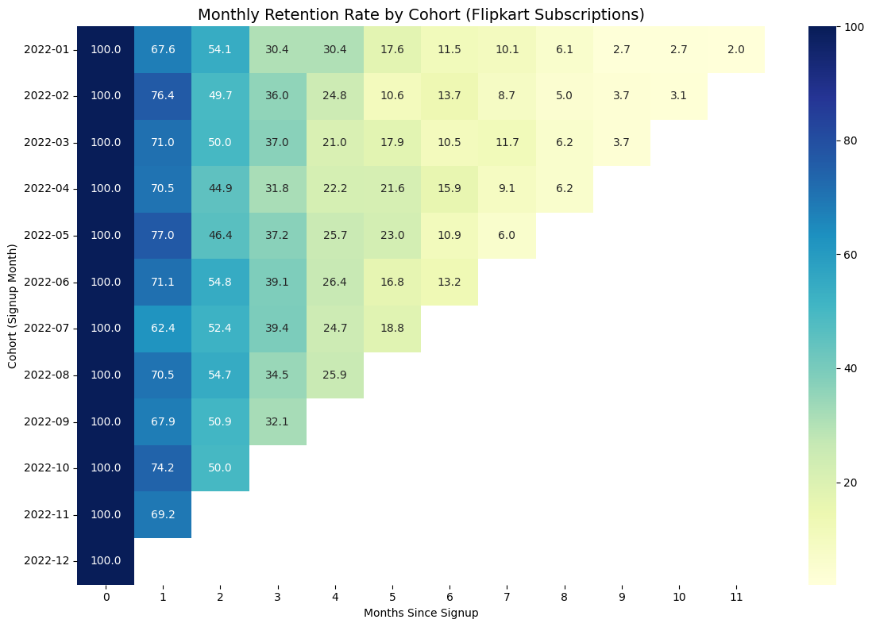

**Plot churn trends to identify drop-off points.**

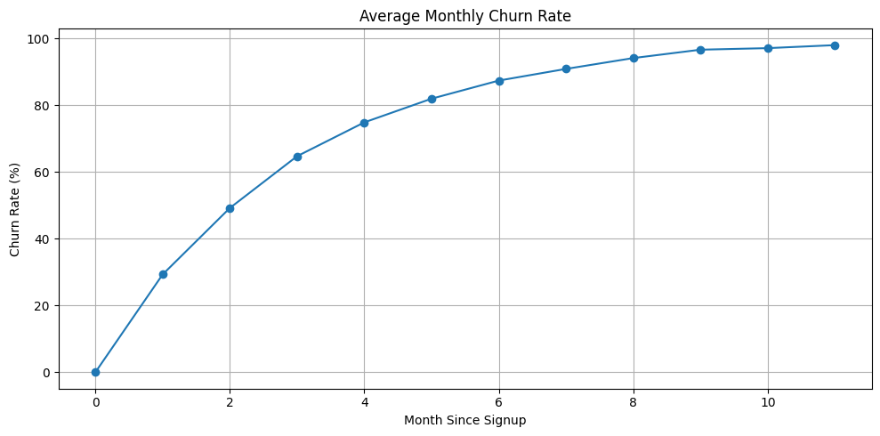

Analyze SuperCoin redemption patterns to assess engagement.

**Retention Observations for Flipkart Plus Members (Hypothetical):**

* Significant drop-off after the first month of membership activation.
* Higher retention among users who frequently redeem SuperCoins.
* Members who engage with exclusive offers and early sale access show better retention.

### **Conclusion**

The cohort analysis reveals a sharp drop in Flipkart Plus member retention after the first month, with retention falling below 20% by month six for most cohorts. Recent cohorts show slight improvement, suggesting better onboarding or offers. To boost retention, focus on first-month engagement, promote SuperCoin usage, and personalize retention strategies. These actions can help reduce churn and increase Customer Lifetime Value (CLV).

**Question 2:**Suppose you find that subscription customers have a 20% higher retention rate after 3 months compared to non-subscription customers. What recommendations would you make to the business based on this finding?

* **Hint:** Consider how the company can capitalise on this insight by encouraging more customers to subscribe, offering promotions, or improving the subscription model.

#### 

#### **Answer:**

To leverage the insight that **subscription customers retain 20% more** after 3 months, and propose actionable strategies that improve overall customer retention, loyalty, and revenue.

### **Insight Summary**

* Subscription users show **20% higher retention** at 3 months compared to regular users.
* Indicates stronger loyalty, better user experience, and likely higher **Customer Lifetime Value (CLV)**.

**Recommendations**

**1. Encourage More Users to Subscribe**

| **Actions** | **Details** |
| --- | --- |
| **On-site Promotion** | Make subscription the default or highlighted choice during checkout |
| **Value Highlighting** | Show cost savings, convenience, and retention benefits |
| **Behavioral Nudges** | Use prompts like: “90% of repeat customers prefer subscriptions” |

#### **2. Offer Conversion Incentives**

| **Action** | **Details** |
| --- | --- |
| **Trial Offers** | Provide 1-month free or discounted subscription to regular users |
| **Product Bundling** | Offer bundles only available via subscription |
| **Loyalty Perks** | Give bonus points or coupons for subscribing |

#### **3. Improve the Subscription Model**

| **Action** | **Details** |
| --- | --- |
| **Flexibility** | Let users pause, skip, or customize deliveries |
| **Predictive Personalization** | Use data to recommend what and when to subscribe to |
| **Better Onboarding** | Educate users on how easy and low-risk the subscription is |

**4. Retarget Non-Subscribers**

| **Action** | **Details** |
| --- | --- |
| **CRM Campaigns** | Target high-frequency or lapsed users with subscription offers |
| **In-App/Email Nudges** | Show subscription savings based on their own order history |
| **Referral Push** | Reward both referrer and referee for joining the subscription program |

**5. Align Growth Strategy Around Subscriptions**

| **Action** | **Details** |
| --- | --- |
| **Spend Allocation** | Invest more in acquiring subscribers via paid campaigns |
| **CLV-Based Targeting** | Prioritize lookalike audiences of long-term subscribers |
| **Performance Measurement** | Track CLV, CAC, and retention uplift separately for subscribers |

**Expected Business Impact**

Boosting subscription adoption by even **10%** could result in:

* Higher overall **retention rate**
* Longer **customer lifetime**
* Improved **CLV to CAC ratio**
* More **predictable revenue**

#### **Scenario 2:**

The company is testing two different **landing pages** for new users. **Version A** emphasises discounted products, while **Version B** highlights the quality and premium nature of products. The company wants to know which version drives more conversions (i.e., purchases).

**Question 1**:  
How would you design an **A/B test** to determine which landing page (Version A or Version B) performs better in terms of conversion rate?

* **Hint**: Define the key metrics (conversion rate), ensure random assignment of users to each version, and run the test over a statistically significant period.

**Answer:**

Determine which landing page **Version A** (discount-focused) or **Version B** (quality-focused) leads to a higher **conversion rate** among new users.

## **Steps in A/B Testing**

### **1. Hypothesis Formation**

* **Null Hypothesis:** There is no difference in conversion rate between Version A and Version B.
* **Alternative Hypothesis:** One version results in a significantly higher conversion rate than the other.

### **2. Create Variants**

* **Version A:** Emphasizes discounts and deals.
* **Version B:** Highlights product quality and premium branding.  
   Both variants must be identical in layout and navigation except for the content focus.

### **3. Random Assignment**

* Randomly assign **new users** to either Version A or Version B.
* Use tools like Google Optimize, Optimizely, or in-house systems to ensure **even traffic distribution** and eliminate selection bias.

### **4. Isolation**

* Ensure that test participants are **not influenced by external factors** like:  
  + Email or app push notifications
  + Personalized ads or retargeting
  + Ongoing promotions not visible to both groups
* This ensures clean data and isolates the **effect of landing page design only**.

### **5. Data Collection**

* Track **key performance indicators (KPIs)** like:  
  + **Conversion rate** (primary metric)
  + Bounce rate, session duration, cart additions (secondary metrics)
* Ensure data collection tools are consistent and reliable across both versions.

### **6. Define the End Period of the Experiment**

* Pre-decide the **duration** based on expected traffic volume and **sample size calculations** (e.g., 95% confidence level, 80% power).
* Common duration: **2–4 weeks**, depending on the user base.
* Don’t stop early unless a statistically significant result emerges.

### **7. Analysis**

* Use statistical tests (e.g., **chi-square or z-test**) to compare conversion rates.
* Check **p-value** to confirm if the result is **statistically significant** (commonly p < 0.05).
* Also consider practical significance: even small gains may matter in high-traffic platforms.

**Conclusion**

If one version significantly outperforms the other, we can **implement it** as the default page.

**Question 2**:  
After running the A/B test, you find that **Version B** has a higher conversion rate, but the difference is not statistically significant. What would you do next? Should the company adopt Version B, or continue with Version A?

* **Hint**: Consider sample size, test duration, and whether further testing (e.g., multivariate testing or extending the test period) might be necessary to confirm the result.

### **Answer:**

Since Version B shows a higher conversion rate but the difference is not statistically significant, I would not immediately recommend switching to it. Here's how I would proceed:

1. **Review the Sample Size and Test Duration**I would first check whether the test ran long enough and had enough users to produce reliable results. A small sample size may lead to inconclusive findings.
2. **Consider Practical Significance**Even if the result isn’t statistically significant, I would evaluate whether the observed improvement in conversion rate is meaningful from a business perspective — for example, whether it could lead to a noticeable revenue increase over time.
3. **Segment the Data**I would analyze whether certain user groups (like mobile users or high-intent shoppers) responded better to Version B. If so, we could consider showing different landing pages to different segments.
4. **Recommend a Follow-up Test**Based on these findings, I would suggest running a longer or more targeted test. We could also test hybrid versions that combine the strong points of both landing pages.
5. **Final Recommendation**Until we have stronger evidence, I would continue using the current version (Version A), while investing in further testing to validate whether Version B or a refined variant could outperform it in the long term.

**Team Members**

Abhiram Soni

Abhishek Mudgulkar

Aniket Kumar

Gautam Anand

Pooja Verma

Moumita Roy